A
REPORT
ON

HAND GESTURES RECOGNITION
USING DEEP LEARNING

BY

Anugnya Pothuganty – 23STUCHH011313
Vyshnavi Vadla - 23STUCHH011325



Faculty of Science & Technology, IFHE University

Contents
- 0 -
Table of Figures - 2 -
ABSTRACT - 3 -
1. Problem Definition & Goal Setting - 4 -
2. Data Acquisition and Preparation - 4 -
2.1 Data Collection Process - 4 -
2.2 Dataset size - 5 -
2.3 Data Preprocessing - 5 -
3. Model Building & Architecture - 6 -
4. Model Compilation and Training - 7 -
5. Evaluation and Optimization - 8 -
6. Deployment and Monitoring - 9 -
6.1 Real-Time Gesture Recognition - 9 -
6.2 Displaying the Prediction - 10 -
6.3 Monitoring the System - 10 -
7. WORKING MODEL AND OUTPUTS - 10 -
7.1 Outputs - 12 -
7.1.1 Paper Gesture Detection - 12 -
7.1.2 Scissors Gesture Detection - 13 -
7.1.3 Rock Gesture Detection - 14 -
7.2 Visualization of Hand Tracking - 14 -
7.3 Performance Observation - 14 -
8. Conclusion - 15 -

Table of Figures
Figure 1: Output(1): Gesture detected - Paper - 13 -
Figure 2 : Output (2) : Gesture Detected - Scissors - 14 -
Figure 3 : Output (3) : Gesture Detected - Rock - 15 -

ABSTRACT

This project is all about making a real, time hand gesture recognition system using deep learning techniques. The goal of the project is to detect and recognize hand gestures through a webcam and showing the recognized gesture immediately on the screen. Hand gesture recognition is a major application of deep learning in the area of computer vision and human, computer interaction. It enables the computer to comprehend the human hand movements and translate them into meaningful commands. In this project, the gesture data were recorded by a webcam and converted into hand features through the Media Pipe library that detects 21 hand landmark points. These landmarks correspond to significant locations of fingers and palm. Landmark coordinates that were collected were converted into numbers and arranged into sequences that indicated different gestures such as rock, paper, and scissors. Reshaping, normalization, and label encoding are some data preprocessing steps that were done to get the dataset ready for training. A deep learning model which is basically neural networks was built to learn the gesture patterns from the collected data. The model was trained by using labelled gesture sequences and then optimized by using the Adam optimizer along with the categorical crossentropy loss function. It was during the training that the model was able to identify different hand gesture patterns very successfully.
After the training had finished, the model was configured to do live gesture prediction. The PC camera kept on tracking the movements of the hand, extracting the hand landmark features and then forwarding them to the trained model for the last step, classification. The ones shown on the screen (gesture + its confidence score) were the results. Through this model we developed, the immense potential of deep learning in the field of gesture recognition and interactive applications was demonstrated. It is possible to contemplate modifications of these models for the recognition of the sign language, virtual interfaces, and smart control systems, applications that require a much broader range of gestures

1. Problem Definition & Goal Setting
Hand gestures are an innate way of human interaction with the world. In many modern applications such as games, virtual reality, smart devices, human-computer interaction systems, etc., the automatic recognition of hand gestures is an added advantage to the system. But for a computer system, the recognition of various hand gestures from the images or videos is not an easy job. The computer should understand the visual patterns such as finger positions, shape of the hands, etc.
The primary challenge of this project is exploring a method that could recognize different hand gestures automatically from the live streaming of a webcam using deep learning techniques. It is very tedious and unreliable if one resort to traditional programming methods by trying to manually write down the rules for each possible hand position.
Deep learning models, on the other hand, can figure out the patterns by themselves directly from image data. Our project aim is to develop a hand gesture recognition system operating in real, time, that is based on deep learning. The system should use a webcam to capture the users hand, detect its features, and then recognize the gesture class among a few given ones.
Three simple hand gestures are taken as a sample for this project:
- Rock
- Paper
- Scissor
The system is capable of collecting the gesture data, training a model using a deep learning technique to recognize the collected gestures, and finally using the model to carry out a prediction using a webcam.
The end product of the project is a system that is capable of recognizing hand gestures in real time and displaying the prediction on the screen.

2. Data Acquisition and Preparation
Data is definitely a major component of any deep learning project. The model needs enough and well, labeled data to be able to learn patterns.
Here, the data was accumulated using a webcam. A Python program was designed on VS Code to record hand movements via webcam live feed. MediaPipe Hands library was employed for detecting hand landmarks. MediaPipe offers a set of 21 primary landmark points per hand, e.g. fingertips knuckles, and wrist positions.

2.1 Data Collection Process
The data collection process followed these steps:
- The webcam was accessed via the OpenCV library.
- MediaPipe detected the hand and extracted 21 landmark points.
- Each landmark contains three values: x, y, and z coordinates.
- These coordinates represent the position of the hand joints in 3D space.
- The landmark values were stored as numerical data instead of saving full images.
For each gesture (rock, paper, scissors), multiple sequences were recorded. Each sequence consisted of 30 frames, which helped the model learn temporal patterns of the gesture.
The data structure looked like this:
data/
rock/
paper/
scissors/
Inside each folder, sequences of gesture data were stored as NumPy files (.npy).
This method is efficient because it stores only the important features of the hand rather than full images.

2.2 Dataset size
For each gesture class:
- Multiple sequences were recorded.
- Each sequence had 30 frames.
- Each frame contained 63 features (21 landmarks × 3 coordinates).
This created a balanced dataset for training.
  - Data Preprocessing
Several preprocessing steps were done before putting the data to the model.
- Reshaping the Data
A deep learning model should at least expect the input to be of one fixed shape. So each sequence is reshaped as:
(30 frames, 63 features)
This structure lets the model learn the hand movement changes over time.
- Normalization
The landmarks coordinates were scaled down. This is to make sure the values are in the same range.
Besides, this step of data normalizing is beneficial to the modeling as it accelerates the training and prevents the model from becoming unstable during training.

- Label Encoding
The classification labels were transformed into numbers.
Example:
- Rock = [1 0 0]
- Paper = [0 1 0]
- Scissors = [0 0 1]
In short, these vectors are one, hot encoded representations of the labels.
4. Train-Test Split
The dataset was separated into two parts:
- The training data (80%) is for the model to learn the features.
- The testing data (20%) is to check how good the model's predictions will be with data that it hasn't seen before.

3. Model Building & Architecture
The core of the system is the deep learning model. In this project, a neural network architecture inspired by Convolutional Neural Networks (CNN) and sequence modeling was used to recognize gestures.
CNNs are commonly used in computer vision tasks because they can automatically learn important visual features from data.
- Convolution Layer
The convolution layer is responsible for detecting important features in the input data. It applies small filters to the input and extracts patterns such as edges, shapes, or movements.
Although this project works with landmark features rather than raw images, the deep learning model still learns patterns from the structured input data.
- Activation Function
Activation function is the next step after convolution.
The most popular activation function is ReLU (Rectified Linear Unit). ReLU introduces non, linearity which allows the model to learn complicated patterns.
Formula: ReLU(x) = max(0, x)
This means negative values become zero while positive values remain unchanged.
- Pooling Layer
Pooling layers reduce the size of the feature maps. This helps in:
- Reducing computational cost
- Preventing overfitting
- Extracting the most important features
Common pooling methods include max pooling and average pooling.
- Flatten Layer
After several convolution and pooling layers, the feature maps are flattened into a single vector. This vector is then passed to the fully connected layers.
- Dense Layers
Dense layers are also called fully connected layers. These layers combine the extracted features and perform classification.
In this project, the dense layer outputs three probabilities corresponding to the three gestures:
- Rock
- Paper
- Scissors
The final layer uses the Softmax activation function, which converts the outputs into probabilities.
Example output:
Rock: 0.02
Paper: 0.97
Scissors: 0.01
The gesture with the highest probability is selected as the final prediction.

4. Model Compilation and Training
Once the architecture is designed, the next step is to compile and train the model.
- Optimizer
The optimizer is used for weight updates during the training phase. Adam is used as the optimizer in this project.
Adam is used as the optimizer because it:
- Converges quickly
- Requires minimal tuning
- Is applicable in most deep learning scenarios
- Loss Function
The loss function indicates how far the prediction is from the actual output.
The loss function used for multi-class classification, as in this problem, is Categorical Cross Entropy.
The training process aims to reduce the value of the loss.
- Epochs:
The number of times the network goes over the entire training data is called an epoch.
The network is trained for approximately 80 epochs in this problem.
During each epoch:
- The model processes the training data.
- Predictions are made.
- Loss is computed.
- Weights are adjusted.
- Batch Size
Batch size refers to the number of data that is processed before adjusting the model weights.
In this project, the batch size was set at:
Batch size = 16
This ensures a fair balance of training speed and stability.
- Training Process
As the model trains, it slowly learns how to relate hand landmark patterns with gestures.
As training progresses, i.e., with every epoch, the training accuracy improves, the loss reduces, and the model improves at recognizing gestures.
Early stopping was also employed to avoid model overfitting. This stops the model when the validation loss stops improving.

5. Evaluation and Optimization
After training, the model performance must be evaluated.
- Accuracy
Accuracy measures how many predictions are correct.
Example:
Accuracy = Correct Predictions / Total Predictions
In this project, the trained model achieved very high accuracy (around 93%–100%).

- Validation loss
Validation loss is used to monitor the performance of the model on unseen data.
When validation loss is increasing while training loss is decreasing, it is an indication that the model is overfitting.
- Confusion Matrix:
Confusion matrix is used to visualize the performance of the model in distinguishing classes. This shows whether the model confuses any gestures.
Example:
Actual | Predicted Rock | Predicted Paper | Predicted Scissors
Rock | High | Low | Low
Paper | Low | High | Low
Scissors | Low | Low | High

- Model Optimization
Some of the techniques used in the optimization of the model are:
- Increase in the size of the dataset
- Adjusting the learning rate
- Use of dropout layers
- Use of early stopping

6. Deployment and Monitoring
After training, the model was saved as a file: rps_lstm.keras
This trained model can be loaded later for real-time predictions.

6.1 Real-Time Gesture Recognition
The process for deployment is as follows:
- The webcam captures the live stream using OpenCV.
- MediaPipe is used to detect the hand and obtain 21 landmarks.
- The coordinates of the landmarks are stored in the frame buffer.
- After the collection of 30 frames, the input is provided to the model.
- The gesture is predicted by the model.

6.2 Displaying the Prediction
The predicted gesture and its confidence score are displayed on the screen.
Example:
ROCK (1.00)
PAPER (0.97)
SCISSORS (0.98)
This makes the system interactive and user-friendly.

6.3 Monitoring the System
The system can be monitored and improved by:
- Adding more gesture classes
- Increasing dataset size
- Improving lighting conditions
- Using more advanced deep learning architectures
Future improvements may include:
- Gesture control for applications
- Sign language recognition
- Mobile deployment using TensorFlow Lite

7. WORKING MODEL AND OUTPUTS
The system works in real time by continuously capturing video frames from the webcam. Each frame is processed to detect the user’s hand and extract important hand landmark features. The MediaPipe Hands library is used to detect 21 hand landmarks, which represent different joints of the fingers and palm.
Each landmark contains x, y, and z coordinates, which describe the position of the hand in space. These coordinates are converted into a numerical feature vector of 63 values (21 × 3).
The system collects 30 consecutive frames of these landmark values to form a sequence. This sequence represents the hand movement over a short period of time. The sequence is then given as input to the trained deep learning model.
The trained model analyses this sequence and predicts the most probable gesture among the three classes:
- Rock
- Paper
- Scissors
The model outputs probability values for each class. The gesture with the highest probability is selected as the final prediction.
The predicted gesture along with its confidence score is displayed on the screen in real time. The webcam window also shows the detected hand landmarks connected by lines to visualize the tracking process.
Real-Time Prediction
The system continuously performs the following steps:
- Capture frame from webcam
- Detect hand landmarks using MediaPipe
- Extract landmark coordinates
- Store landmark data for 30 frames
- Send the sequence to the trained deep learning model
- Predict the gesture
- Display prediction and confidence score on the screen
This process repeats continuously, allowing the system to recognize gestures instantly.

7.1 Outputs
The model successfully recognizes the gestures with high confidence values. Some example outputs observed during testing are shown below.

7.1.1 Paper Gesture Detection
The system correctly detects the paper gesture when the hand is fully open. The model prediction shows a high probability for paper while the probabilities for rock and scissors are close to zero.
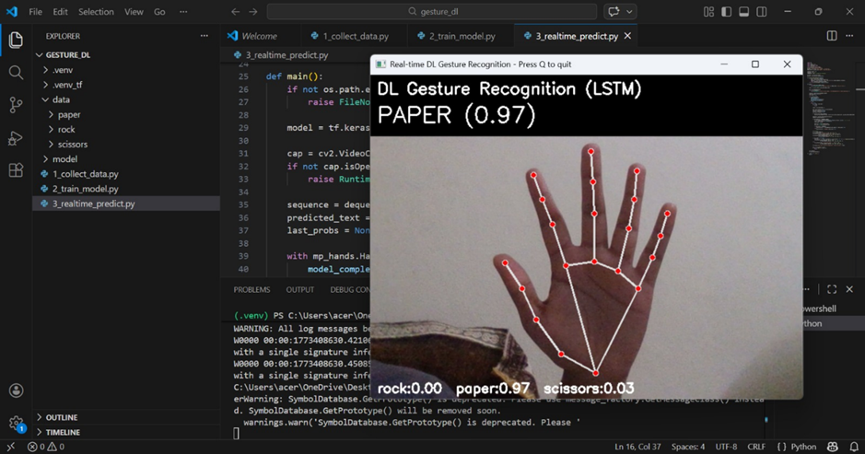Figure 1: Output(1): Gesture detected - Paper
Output:
- Rock: 0.00
- Paper: 0.97
- Scissors: 0.03
This indicates that the model confidently recognizes the open hand gesture as paper.

7.1.2 Scissors Gesture Detection
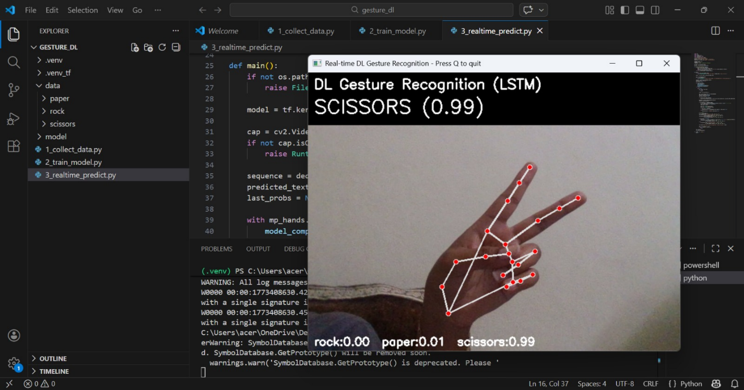
When the user shows two fingers representing scissors, the model correctly predicts the gesture with very high confidence.
Figure 2 : Output (2) : Gesture Detected - Scissors

Output:
- Rock: 0.00
- Paper: 0.01
- Scissors: 0.99
The high probability value confirms that the model successfully identifies the scissors gesture.

7.1.3 Rock Gesture Detection
When the user closes the hand into a fist, the system recognizes the gesture as rock.
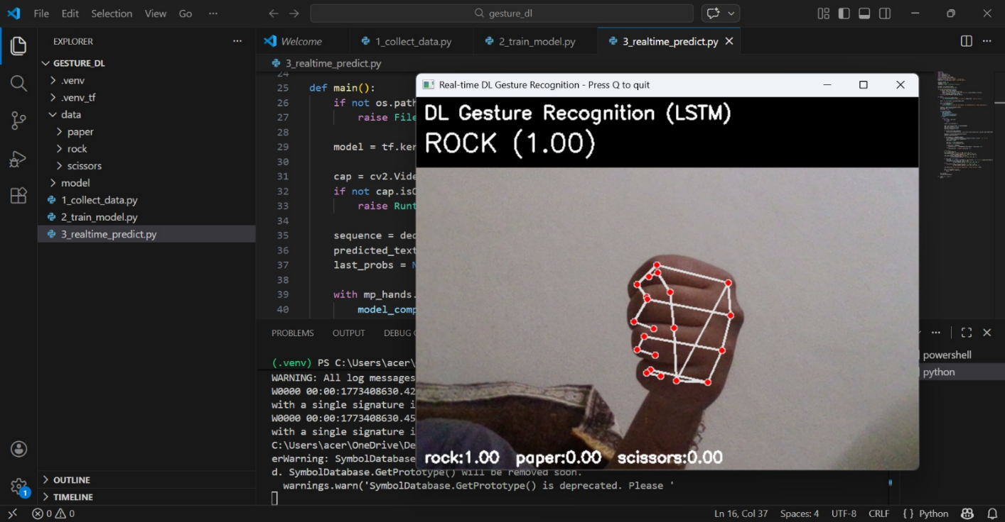Figure 3 : Output (3) : Gesture Detected - Rock

Output:
- Rock: 1.00
- Paper: 0.00
- Scissors: 0.00
This shows that the model predicts the rock gesture with full confidence.

7.2 Visualization of Hand Tracking
In the webcam output window, the detected hand landmarks are displayed as red points connected with white lines. This helps visualize how the system tracks finger positions and hand structure.
The hand skeleton representation confirms that the MediaPipe library is accurately detecting hand joints. These landmarks form the input features for the deep learning model.

7.3 Performance Observation
During testing, the system performed very well under normal lighting conditions. The model was able to recognize gestures quickly with very high accuracy. The prediction confidence values were typically above 0.95, indicating strong model performance.
The system responded in real time with minimal delay, making it suitable for interactive applications.

8. Conclusion
This project is successful in illustrating how deep learning is applied for hand gesture recognition in real-time. The application processes the gesture data using a webcam, trains a deep learning model, and then makes predictions.
The application of MediaPipe for hand tracking, deep learning for gesture classification, and OpenCV for processing videos in real-time resulted in the development of an efficient gesture recognition system.
The project illustrates the application of deep learning in computer vision and how deep learning networks can be used for learning complex patterns in images.
The application of such systems is diverse, ranging from human-computer interaction, gaming, and virtual reality, to accessibility technologies.

